1. **Agenda**:
   1. Let’s create repository to connect with DB.
2. 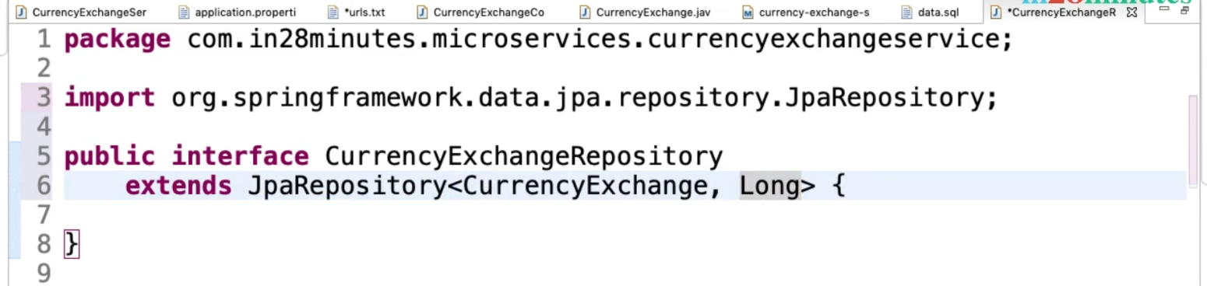
3. 
4. 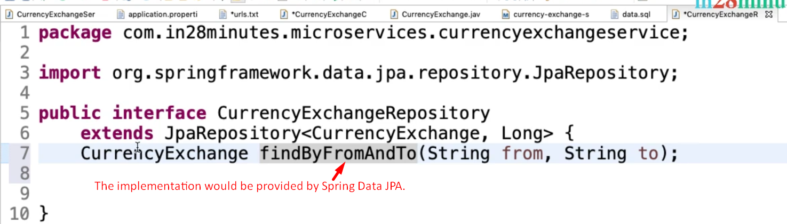
5. 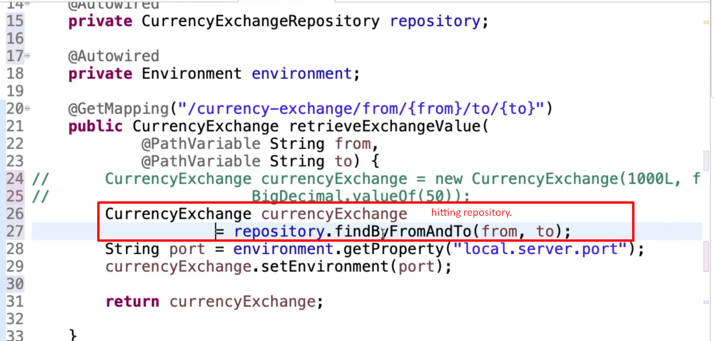
6. 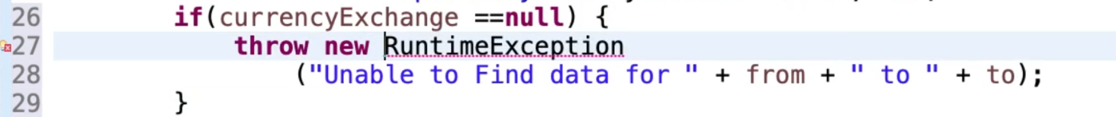
7. 